**10 Mbps** 

**10 Mbps** delivers internet download speeds at approximately **10** megabits/second and upload speeds up to 1 **megabit**/second. That means a **10** MB file will take 8 seconds to load. This speed is ideal for small businesses with very few employees, and it functions through a DSL internet connection with a unique IP address.

**100 Mbps**

For most people, **100 Mbps** is fast enough for web browsing, checking social media, and watching YouTube videos. It's even fast enough for a whole family to watch a few different streaming shows, even in HD quality. But fast is relative to how many people and devices are using your Wi-Fi network.

# **Medium Access Control Sublayer (MAC sublayer)**

The medium access control (MAC) is a sublayer of the data link layer of the open system interconnections (OSI) reference model for data transmission. It is responsible for flow control and multiplexing for transmission medium. It controls the transmission of data packets via remotely shared channels. It sends data over the network interface card.

## MAC Layer in the OSI Model

The Open System Interconnections (OSI) model is a layered networking framework that conceptualizes how communications should be done between heterogeneous systems. The data link layer is the second lowest layer. It is divided into two sublayers −

* The logical link control (LLC) sublayer
* The medium access control (MAC) sublayer

The following diagram depicts the position of the MAC layer −

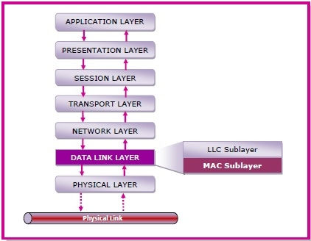

## Functions of MAC Layer

* It provides an abstraction of the physical layer to the LLC and upper layers of the OSI network.
* It is responsible for encapsulating frames so that they are suitable for transmission via the physical medium.
* It resolves the addressing of source station as well as the destination station, or groups of destination stations.
* It performs multiple access resolutions when more than one data frame is to be transmitted. It determines the channel access methods for transmission.
* It also performs collision resolution and initiating retransmission in case of collisions.
* It generates the frame check sequences and thus contributes to protection against transmission errors.

## MAC Addresses

MAC address or media access control address is a unique identifier allotted to a network interface controller (NIC) of a device. It is used as a network address for data transmission within a network segment like Ethernet, Wi-Fi, and Bluetooth.

MAC address is assigned to a network adapter at the time of manufacturing. It is hardwired or hard-coded in the network interface card (NIC). A MAC address comprises of six groups of two hexadecimal digits, separated by hyphens, colons, or no separators. An example of a MAC address is 00:0A:89:5B:F0:11.

**Brief survey of other LAN system**

* **Token Ring**
* **FDDI**
* **ATM**
* **Fiber channel**

## Ring Topology

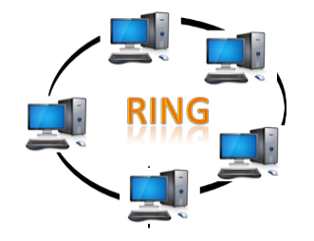

* Ring topology is like a bus topology, but with connected ends.
* The node that receives the message from the previous computer will retransmit to the next node.
* The data flows in one direction, i.e., it is unidirectional.
* The data flows in a single loop continuously known as an endless loop.
* It has no terminated ends, i.e., each node is connected to other node and having no termination point.
* The data in a ring topology flow in a clockwise direction.
* The most common access method of the ring topology is **token passing**.
  + **Token passing:** It is a network access method in which token is passed from one node to another node.
  + **Token:** It is a frame that circulates around the network.

### **Working of Token passing**

* A token moves around the network, and it is passed from computer to computer until it reaches the destination.
* The sender modifies the token by putting the address along with the data.
* The data is passed from one device to another device until the destination address matches. Once the token received by the destination device, then it sends the acknowledgment to the sender.
* In a ring topology, a token is used as a carrier.

### **Advantages of Ring topology:**

* **Network Management:** Faulty devices can be removed from the network without bringing the network down.
* **Product availability:** Many hardware and software tools for network operation and monitoring are available.
* **Cost:** Twisted pair cabling is inexpensive and easily available. Therefore, the installation cost is very low.
* **Reliable:** It is a more reliable network because the communication system is not dependent on the single host computer.

### **Disadvantages of Ring topology:**

* **Difficult troubleshooting:** It requires specialized test equipment to determine the cable faults. If any fault occurs in the cable, then it would disrupt the communication for all the nodes.
* **Failure:** The breakdown in one station leads to the failure of the overall network.
* **Reconfiguration difficult:** Adding new devices to the network would slow down the network.
* **Delay:** Communication delay is directly proportional to the number of nodes. Adding new devices increases the communication delay.

# **Fiber Distributed Data Interface (FDDI)**

Fiber Distributed Data Interface (FDDI) is a set of ANSI and ISO standards for transmission of data in local area network (LAN) over fiber optic cables. It is applicable in large LANs that can extend up to 200 kilometers in diameter.

## Features

* FDDI uses optical fiber as its physical medium.
* It operates in the physical and medium access control (MAC layer) of the Open Systems Interconnection (OSI) network model.
* It provides high data rate of 100 Mbps and can support thousands of users.
* It is used in LANs up to 200 kilometers for long distance voice and multimedia communication.
* It uses ring based token passing mechanism and is derived from IEEE 802.4 token bus standard.
* It contains two token rings, a primary ring for data and token transmission and a secondary ring that provides backup if the primary ring fails.
* FDDI technology can also be used as a backbone for a wide area network (WAN).

The following diagram shows FDDI −

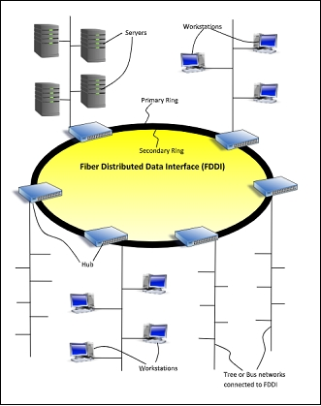

## Frame Format

The frame format of FDDI is similar to that of token bus as shown in the following diagram −

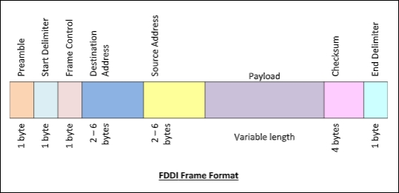

The fields of an FDDI frame are −

* **Preamble:** 1 byte for synchronization.
* **Start Delimiter:** 1 byte that marks the beginning of the frame.
* **Frame Control:** 1 byte that specifies whether this is a data frame or control frame.
* **Destination Address:** 2-6 bytes that specifies address of destination station.
* **Source Address:** 2-6 bytes that specifies address of source station.
* **Payload:** A variable length field that carries the data from the network layer.
* **Checksum:** 4 bytes frame check sequence for error detection.
* **End Delimiter:** 1 byte that marks the end of the frame.

# ATM Networks

## ATM and ATM Networks

ATM stands for Asynchronous Transfer Mode. It is a switching technique that uses time division multiplexing (TDM) for data communications.

ATM networks are connection oriented networks for cell relay that supports voice, video and data communications. It encodes data into small fixed - size cells so that they are suitable for TDM and transmits them over a physical medium.

The size of an ATM cell is 53 bytes: 5 byte header and 48 byte payload. There are two different cell formats - user-network interface (UNI) and network-network interface (NNI). The below image represents the Functional Reference Model of the Asynchronous Transfer Mode.

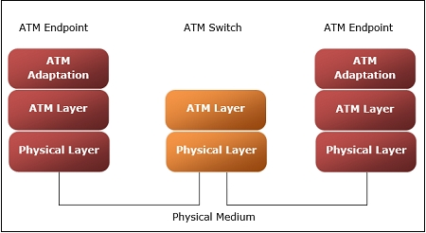

### Benefits of ATM Networks are

* It provides the dynamic bandwidth that is particularly suited for bursty traffic.
* Since all data are encoded into identical cells, data transmission is simple, uniform and predictable.
* Uniform packet size ensures that mixed traffic is handled efficiently.
* Small sized header reduces packet overload, thus ensuring effective bandwidth usage.
* ATM networks are scalable both in size and speed.

### ATM reference model comprises of three layers

* **Physical Layer −** This layer corresponds to physical layer of OSI model. At this layer, the cells are converted into bit streams and transmitted over the physical medium. This layer has two sub layers: PMD sub layer (Physical Medium Dependent) and TC (Transmission Convergence) sub layer.
* **ATM Layer −**This layer is comparable to data link layer of OSI model. It accepts the 48 byte segments from the upper layer, adds a 5 byte header to each segment and converts into 53 byte cells. This layer is responsible for routing of each cell, traffic management, multiplexing and switching.
* **ATM Adaptation Layer (AAL) −**This layer corresponds to network layer of OSI model. It provides facilities to the existing packet switched networks to connect to ATM network and use its services. It accepts the data and converts them into fixed sized segments. The transmissions can be of fixed or variable data rate. This layer has two sub layers − Convergence sub layer and Segmentation and Reassembly sub layer.
* **ATM endpoints −** It contains ATM network interface adaptor. Examples of endpoints are workstations, routers, CODECs, LAN switches, etc.
* **ATM switch −**It transmits cells through the ATM networks. It accepts the incoming cells from ATM endpoints (UNI) or another switch (NNI), updates cell header and retransmits cell towards destination.

# **Fiber Cables**

Optical fiber cables are transparent, flexible fibers made up of glass or plastic through which light waves can pass. A bunch of fiber optic cables is shown in the following diagram −

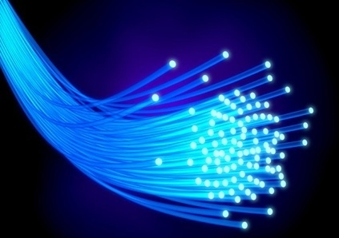

## Structure of a Fiber – Optic Cable

A cross section of a fiber optic cable reveals three parts −

* **Core −** It is the innermost portion of an optical fiber through which light propagates. It is cylindrical in shape and it made up of a flexible glass of high refractive index. The diameter of the core of a single mode fiber is 8 – 10 μm while multimode fibers are 50 μm in diameter. It is also called the optical waveguide since it is the main channel through which light signals are transmitted.
* **Cladding −** The core is surrounded by a glass cladding. The glass of cladding has a lower refractive index than the core. This enables total internal reflection of light waves in the core, and eventually propagation of light waves within the core.
* **Outer Coating or Jacket −** The outer jacket is a thin plastic sheath or coating that is opaque to light. It prevents light rays from outside to enter the optical fiber. Fibers are typically bundles together, where each bundle is covered by a protective outer sheath that prevents the fibers from physical damage.

The following figure gives a three-dimensional section of a fiber – optic cable.

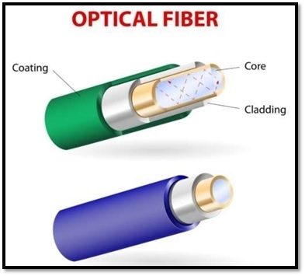

## Connection of Optical Fibers

Fiber optic cables need to be connected so that there is no leakage of light signals. There are three types of connectors −

* Subscriber Channel (SC) Connector: used in cable TV
* Straight – Tip (ST) Connector: used for connecting to networking devices
* MT – RJ Connector: similar to RJ connector

## Types of Optical Fibers

There are two types of fibers −

* **Step-index fiber** : In these, the refractive index of the core is constant and undergoes an abrupt change at the interface with the cladding.
* **Graded-index fiber**: The refractive index of the core varies in a radial manner from the center. The fiber is densest at the core and becomes rarer towards the edge of the core.

Both of these are further divided into two categories depending upon propagation modes of the fibers −

* Single-mode fiber
* Multi-mode fiber